Site Monitor v1.0.12

User Guide

# Introduction

Site Monitor is intended to allow shopping sites to be searched for potentially infringing content relating to illegal wildlife trade. Once a search has been successfully performed, the results themselves can be further searched or examined more closely. Site Monitor supports immediate searches that return results as soon as the search completes, but also allows monitoring to be performed. Monitoring allows searches to be setup that are performed at regular intervals with the results from each scheduled search being available for further searching or examination. All of the results are retained unless intentionally removed.

The capabilities of the shopping sites themselves are used to perform the searches and the results returned are based on the sites own search mechanism. Only the top 100 entries at most are currently returned for each search. This may be the first page of results for a site or a single scroll down where a site has a continuous search results page.

# Supported Sites

Fifteen sites are currently defined within the application. The default request location and support status of these sites is as follows:

|  |  |  |
| --- | --- | --- |
| Site | Default geolocation | Status |
| Alibaba | China | Supported |
| Bukalapak | Indonesia | Supported |
| Carousell | Singapore | Supported |
| Shopee Brazil | Brazil | Available* |
| Shopee Chile | Chile | Available* |
| Shopee Columbia | Columbia | Available* |
| Shopee Indonesia | Indonesia | Available* |
| shopee malaysia | Malaysia | Pending |
| Shopee Mexico | Mexico | Available* |
| shopee philippines | Philippines | Pending |
| Shopee Singapore | Singapore | Available* |
| Shopee Taiwan | Taiwan | Pending |
| Shopee Thailand | Thailand | Pending |
| Shopee Vietnam | Vietnam | Pending |
| Tokopedia | Indonesia | Supported |

*Some Shopee sites are available but have a higher than acceptable failure rate.

# Starting a Site Search

A new site search can be initiated from the Search page by selecting the Search option in the navigation panel of the left.

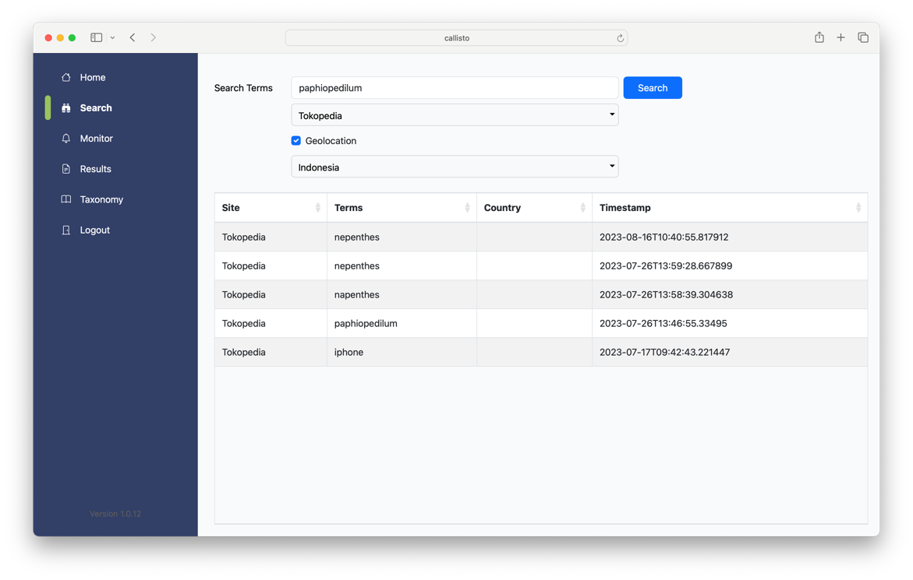

Simply enter the required search terms in the “Search Terms” field and then select the site to search in the drop-down list below.



Once both of these details have been entered, then the “Search” button will be enabled, and the search can be started by either pressing the return key or clicking on the button.

A progress wheel will be displayed while the search is taking place and all of the control on the page will be disabled.

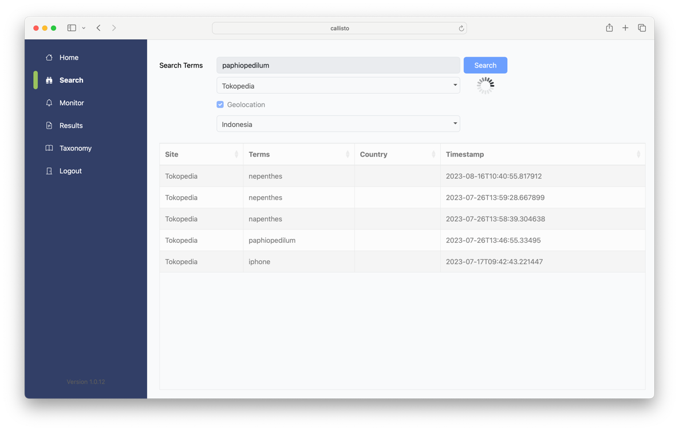

A new entry will appear in the “Search History” list and all of the controls will be enabled when the search completes.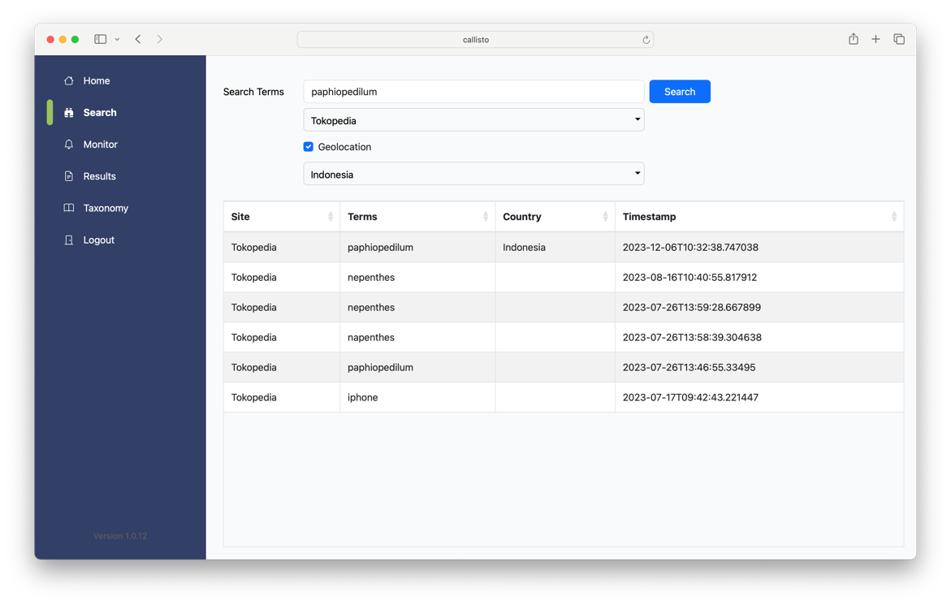

# Geolocation

Some sites either do not work well from some locations or show different results depending on the location of the request. It is possible to choose the location from where the request can be made by ticking the “Geolocation” checkbox and then choosing the country from the dropdown list below. Choosing the target site for a search also sets a default location that can optionally be used by ticking the “Geolocation” checkbox.

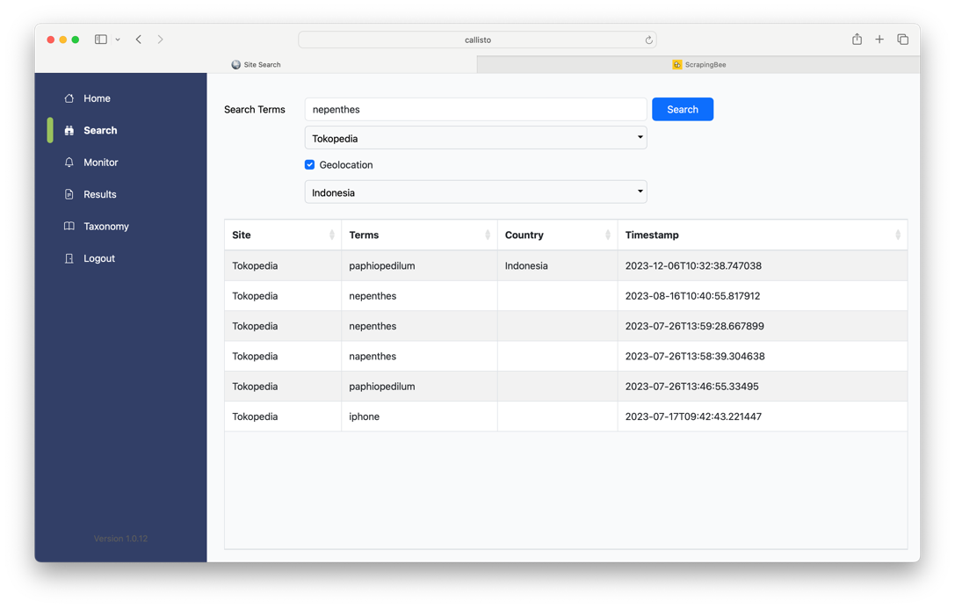

The country chosen for a search is shown in the search history list. An empty “Geolocation” field in list indicates that the default location has been used.



# Viewing Search Results

Results from an individual site search can be viewed by double-clicking on the search entry in the “Search History” list on the Search page. This will bring up a new page showing all of the results for that search. The “Search Terms” and the “Site Name” appear at the top of the “Search Results” page.

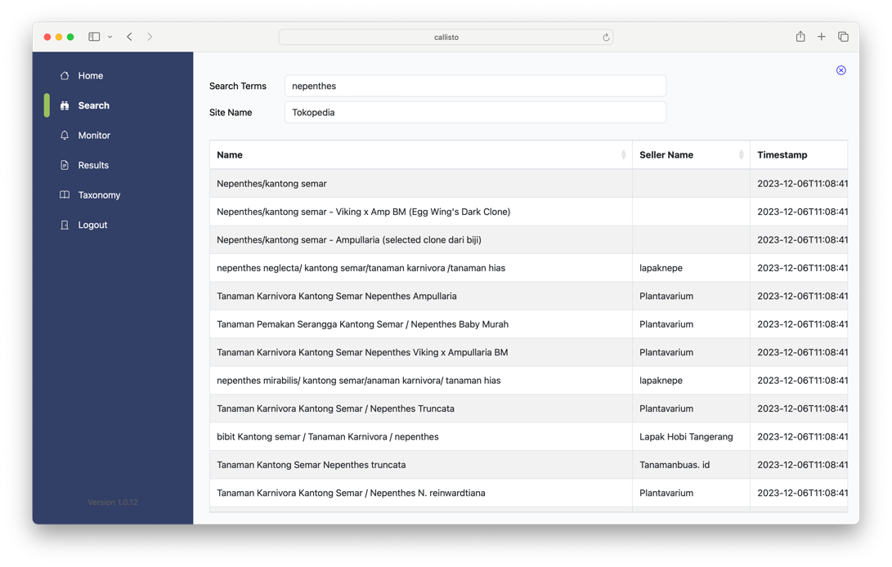

Scrolling up or down within the results list allows more results to be seen and it is also possible to view an individual result by double-clicking on that entry in the list.

The individual “Item” page can be closed by clicking on the “X” button in the right top right corner of the page, returning to the “Search Results” page.

# Finding Search Results by Search Terms, Name or Seller

The “Results” navigation menu option allows for existing search results to be found by using a combination of the Search Terms, Name or Seller Name within those results.

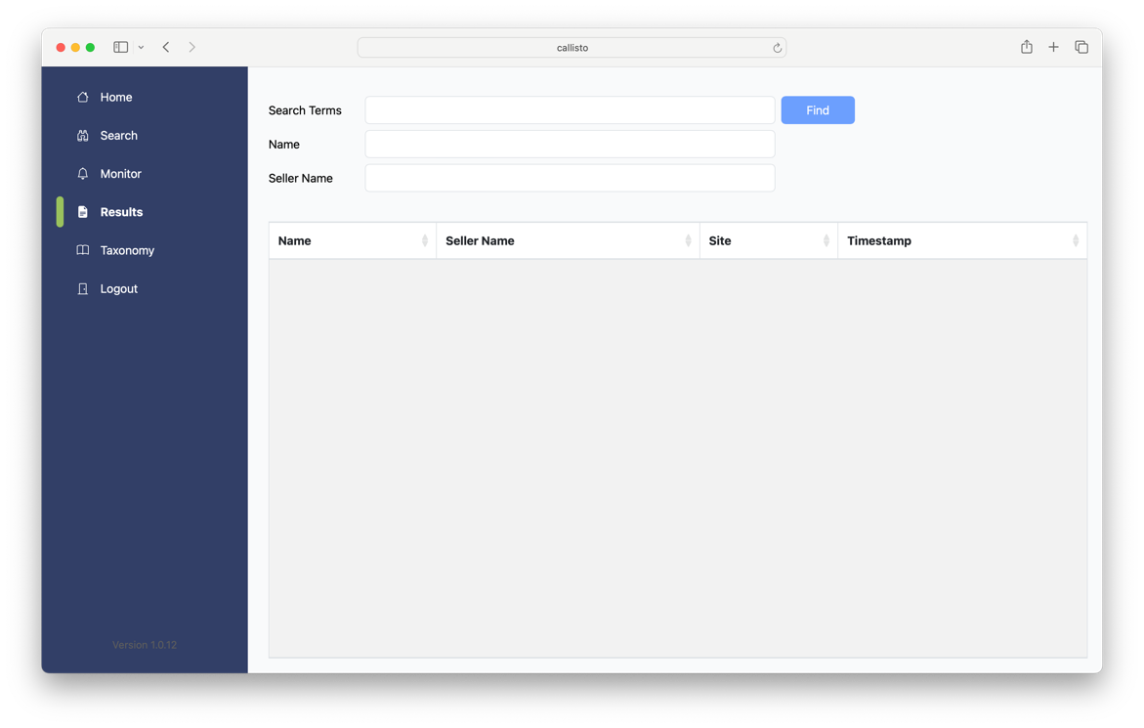

To find specific results, for example by name, enter the details in the appropriate search fields and then press the “Search” button. A list of the found results will then be displayed.

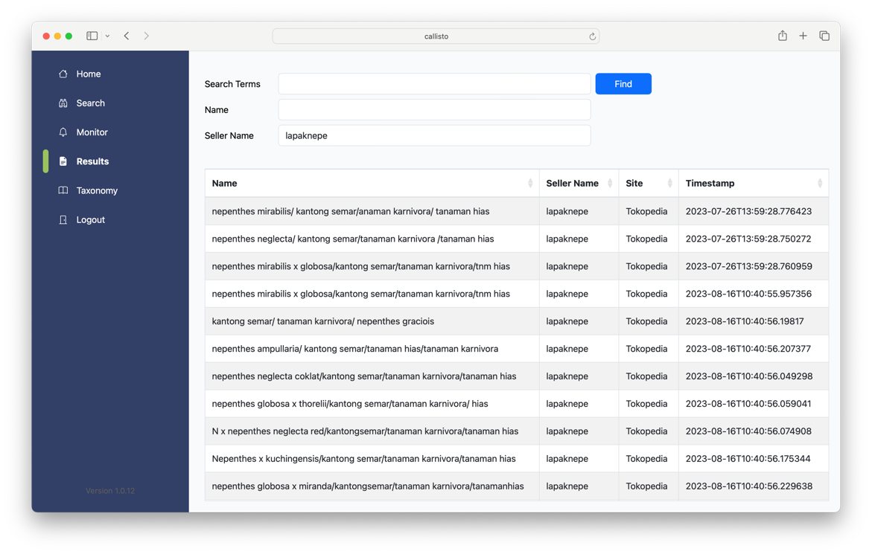

# Creating a Monitoring Search

A new monitoring search can be created from the Monitor page by selecting the Monitor option in the navigation panel of the left.

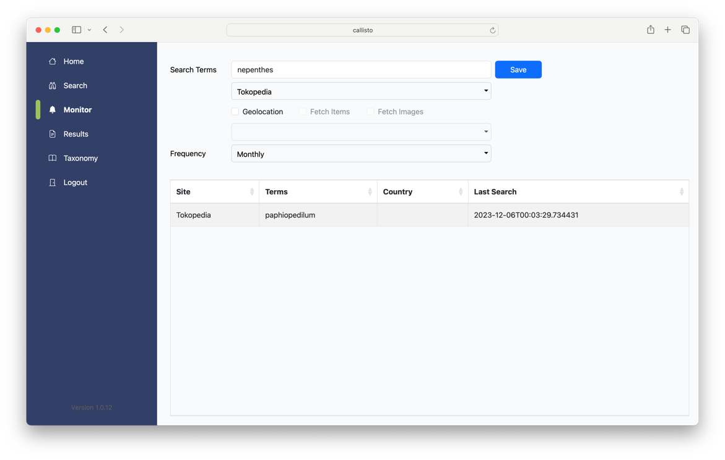

Simply enter the required search terms in the “Search Terms” field and then select the site to search in the drop-down list below. Finally, choose the frequency of the search from Daily, Weekly, Fortnightly or Monthly.

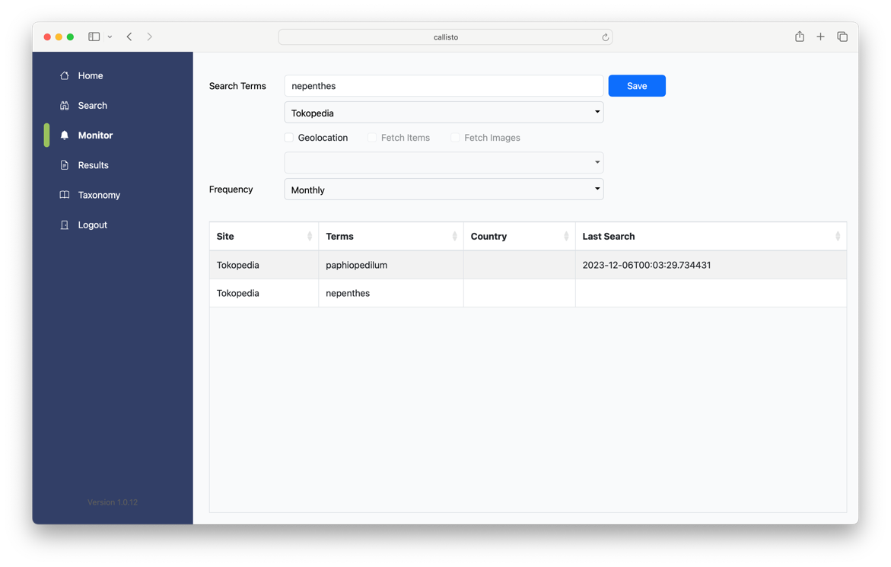

Once both of these details have been entered, then the “Save” button will be enabled, and the monitoring search can be created by either pressing the return key or clicking on the button.

The first search will not start immediately but will wait until the next available opportunity to run. It will be necessary to return later to view the first set of results. A date and time will be present in the “Last Search” field to indicate then the search was last performed.

# Viewing Monitoring Results

The results from a monitoring search can be viewed from the Monitor page by selecting the Monitor option in the navigation panel of the left.

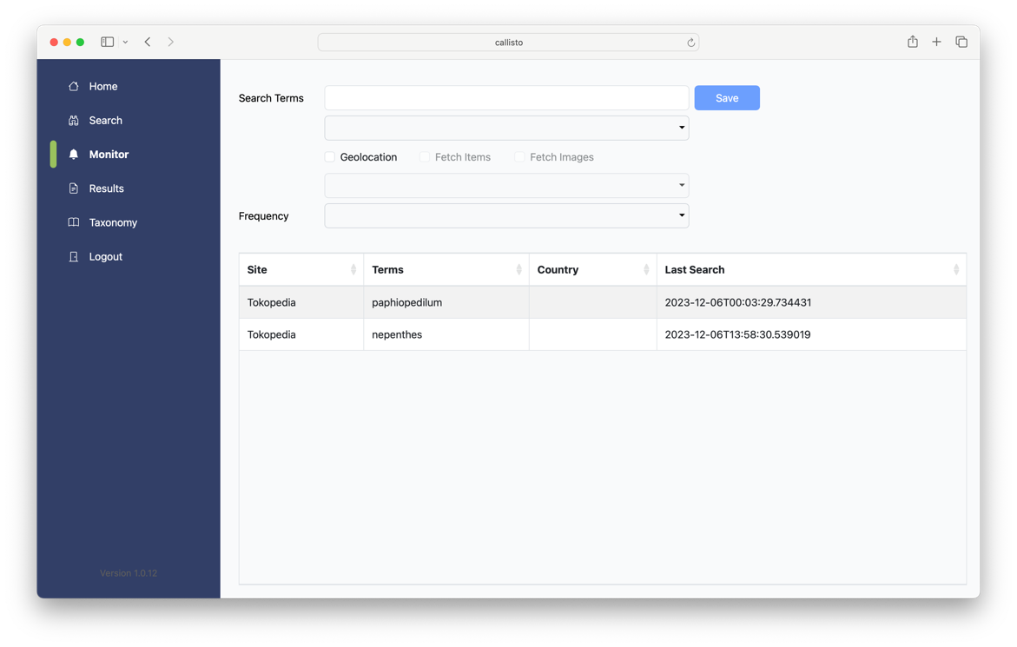

Simply double-click the required entry in the list of monitoring searches to open the details page for that particular monitoring search.

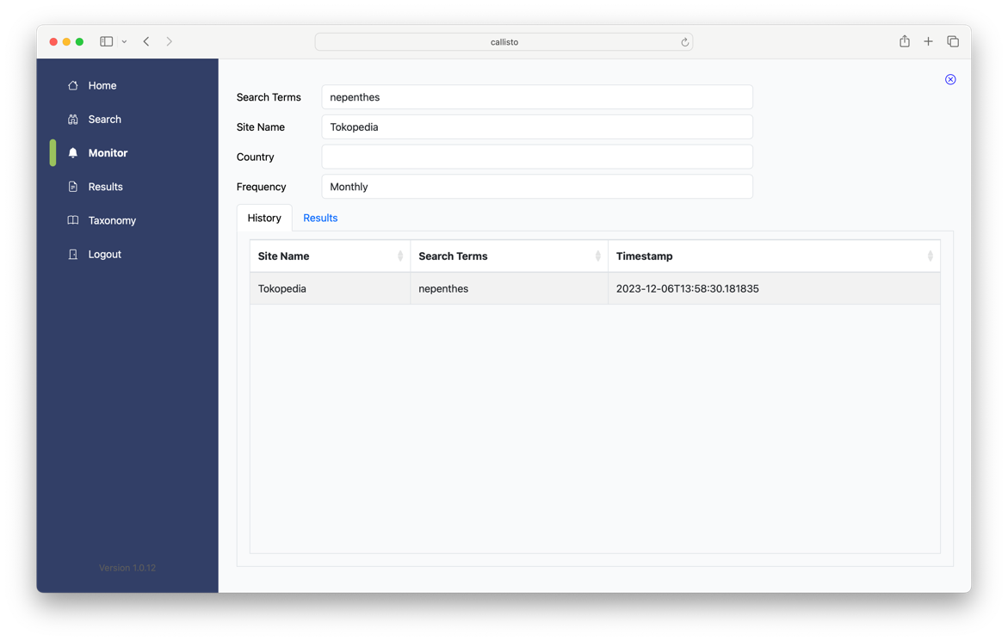

The details of the search will appear within the top section of the page, with two tabs for “History” and “Results” showing at the bottom.

The “History” tab shows the history for the monitoring search and contains an entry for every time that the search has run. The most recent entry is shown at the top of the list.

The results for an individual monitoring search run can be viewed by double-clicking on the appropriate entry in the list on the “History” tab.

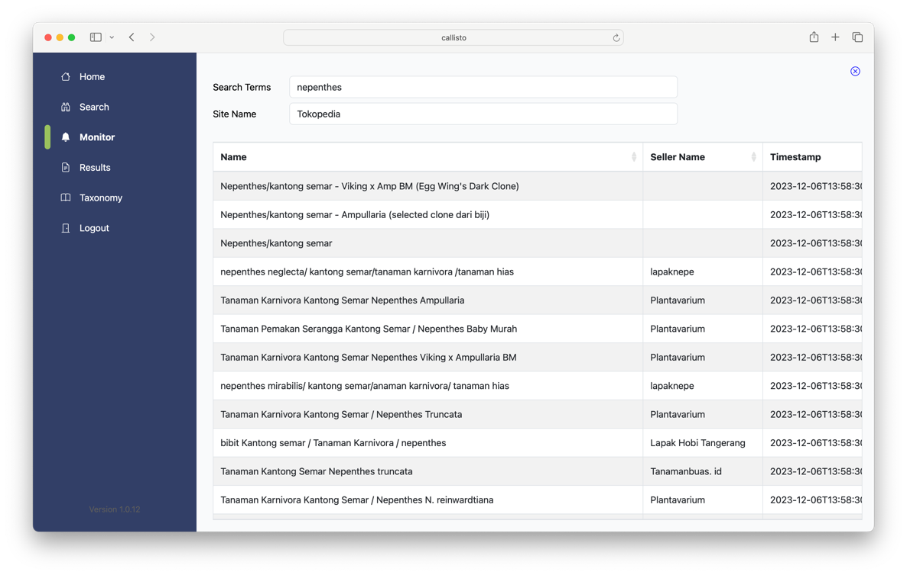

Clicking on the “X” button in the top right corner of the page will return to the monitoring search details page. Select the “Results” tab on that page will then show all of the results for the monitoring search across all runs of that search.

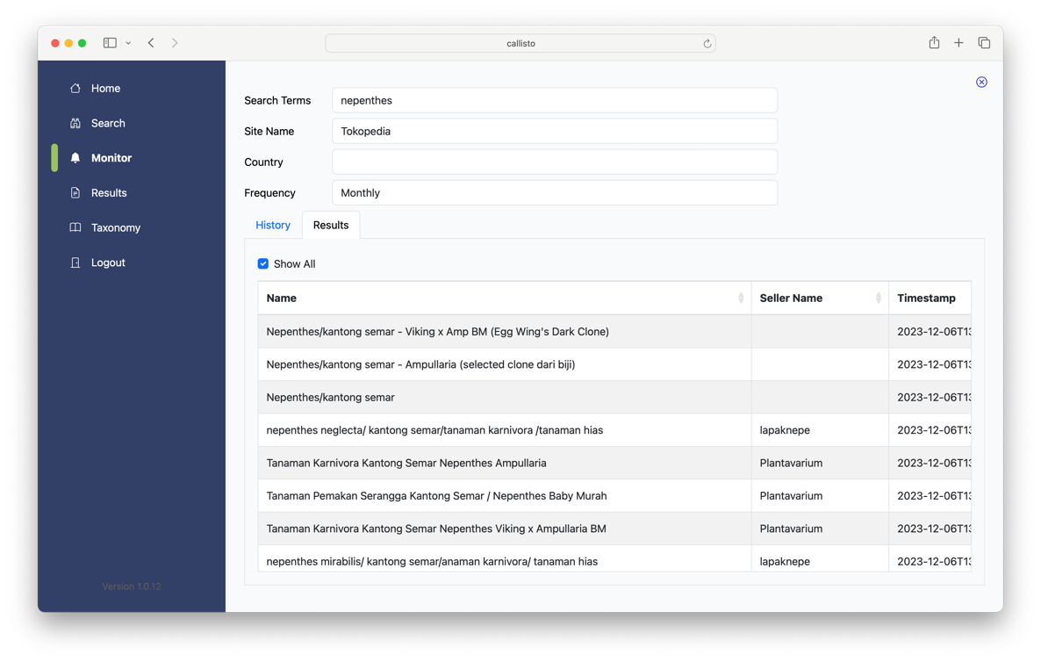

Unticking the “Show All” option at the top of the “Results” tab will cause the list to display only the unique results across all of the runs for that monitoring search.

# Taxonomy Searches

The “Taxonomy” page allows searches to be performed against the three taxonomy databases of AmphibiaWeb, International Plant Names Index and The Reptile Database.

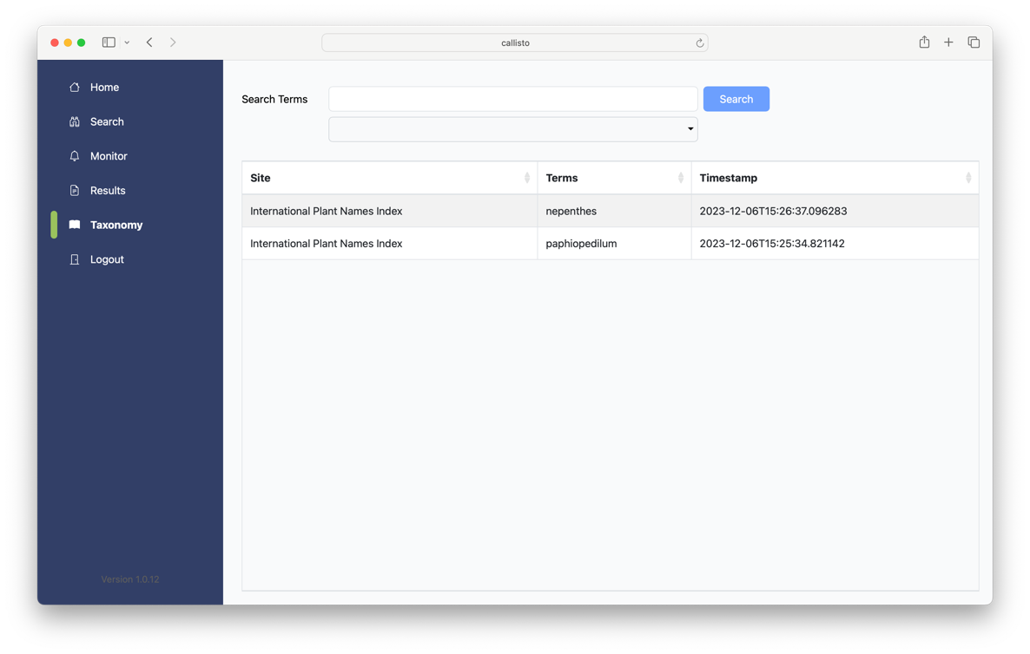

Simply enter the required search terms in the “Search Terms” field and then select the database to search in the drop-down list below.

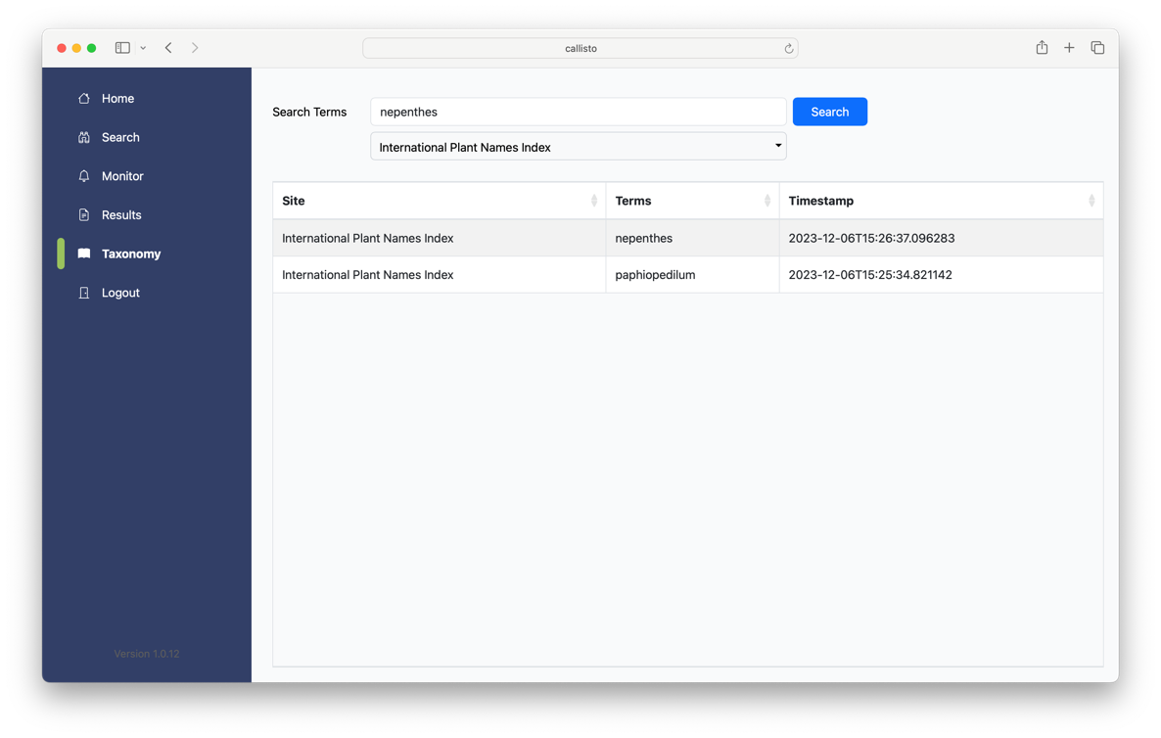

Once both of these details have been entered, then the “Search” button will be enabled, and the search can be started by either pressing the return key or clicking on the button.

A progress wheel will be displayed while the search is taking place and all of the controls on the page will be disabled.

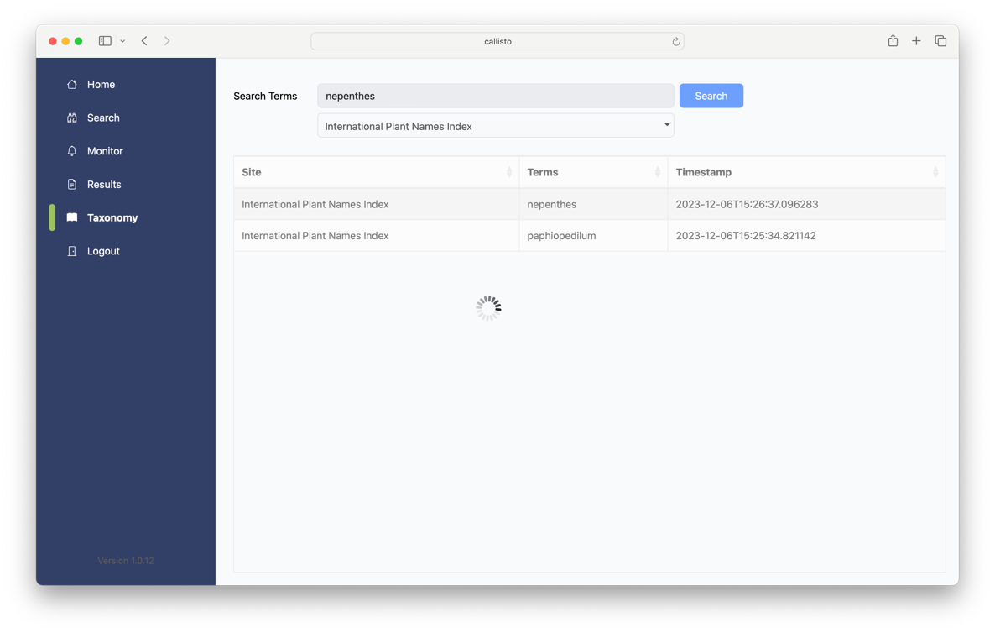

All of the controls will be enabled once the search completes, and new entry will appear in the list for a new search, or an existing entry will be updated.

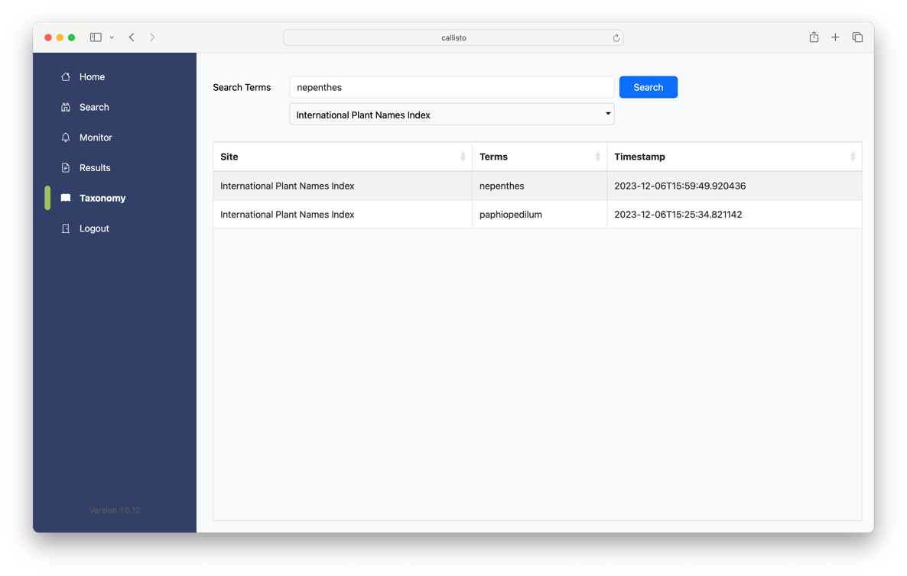

The results for a taxonomy database search can be viewed by double-clicking on the appropriate entry in the list on the Taxonomy page.

